**Brain Tumor Segmentation**

| Name | ID | CRN | Time |
| --- | --- | --- | --- |
| Mostafa Tarek | 94071 | 6314 | 9 - 11 |
| Mohamed Ezz | 94303 | 6314 | 9 - 11 |
| Amr Samir | 90369 | 6316 | 1 - 3 |
| Abdelrahman Ahmed | 94218 | 6316 | 1 - 3 |

Doctor: Muhammad Deif

ENG: Mariam Essam

**Abstract**

This study focuses on the segmentation of brain tumors in magnetic resonance (MR) images using a deep learning approach, specifically employing the UNet architecture. The dataset utilized in this research is the LGG Segmentation Dataset, as detailed in the works of Mateusz Buda, Ashirbani Saha, and Maciej A. Mazurowski, published in Computers in Biology and Medicine (2019) and Journal of Neuro-Oncology (2017). The dataset comprises MR images and manually annotated fluid-attenuated inversion recovery (FLAIR) abnormality segmentation masks obtained from The Cancer Imaging Archive (TCIA). These images represent 110 patients from The Cancer Genome Atlas (TCGA) lower-grade glioma collection, ensuring the availability of FLAIR sequences and genomic cluster data. The associated tumor genomic clusters and patient data are provided in a data.csv file. The study applies UNet for automated brain tumour segmentation in order to improve understanding of the relationship between genomic subtypes of lower-grade gliomas and form features retrieved using deep learning techniques. The findings of this study provide important insights into the potential relationship between tumour form characteristics, genetic subtypes, and patient outcomes, supporting developments in the field of radiogenomics for lower-grade gliomas.

**Introduction**

Brain tumors, particularly lower-grade gliomas, present a formidable challenge in the realm of medical diagnostics and treatment planning. The precise delineation of tumor boundaries from magnetic resonance (MR) images is crucial for effective clinical decision-making. It offers essential insights into the spatial extent of the tumor and assists in formulating optimal treatment strategies. The emergence of deep learning techniques, including the UNet architecture, has revolutionized medical image segmentation. This development presents promising opportunities for automating the intricate task of tumor delineation, contributing to advancements in clinical practice.

This research addresses the critical issue of brain tumor segmentation through the lens of UNet, a convolutional neural network (CNN) designed for biomedical image analysis. The dataset under scrutiny is the Lower-Grade Glioma (LGG) Segmentation Dataset, meticulously curated and annotated in the studies by Mateusz Buda, Ashirbani Saha, and Maciej A. Mazurowski. Their works, published in Computers in Biology and Medicine (2019) and the Journal of Neuro-Oncology (2017), form the cornerstone of this investigation.

The LGG Segmentation Dataset is derived from The Cancer Imaging Archive (TCIA) and comprises MR images coupled with manual fluid-attenuated inversion recovery (FLAIR) abnormality segmentation masks. The dataset encapsulates 110 patients enlisted in The Cancer Genome Atlas (TCGA) lower-grade glioma collection, ensuring a comprehensive representation of diverse cases. Notably, the inclusion criteria mandate the availability of FLAIR sequences and genomic cluster data for each patient.

The intrinsic link between tumor genomic clusters and shape features automatically extracted by deep learning algorithms serves as a focal point for this study. The genomic subtypes of lower-grade gliomas hold profound implications for prognosis and treatment response. By leveraging the capabilities of UNet, we aim to decipher the nuanced association between tumor shape characteristics and genomic subtypes. This investigation is motivated by the premise that gaining an in-depth understanding of these associations can potentially unlock novel insights into the intricate landscape of lower-grade gliomas, thereby facilitating more personalized and effective therapeutic interventions.

The significance of this research extends beyond the realm of segmentation algorithms; it delves into the realm of radiogenomics, seeking to bridge the gap between imaging features and underlying molecular characteristics. The ultimate goal is to enhance the clinical utility of non-invasive imaging in characterizing lower-grade gliomas, thereby contributing to the burgeoning field of precision medicine. Through this exploration, we aspire to uncover patterns, correlations, and predictive markers that can augment the diagnostic and prognostic armamentarium for clinicians grappling with the intricacies of lower-grade gliomas.

**Methodology**

**1. Data Preprocessing**

* Start by reading images and storing their paths in variables.
* Resize all images and masks to a width and height of 256.
* Convert the images to RGB format and the masks to grayscale.
* Normalize both the images and masks, adjusting pixel values to range from 0 to 1."

**2. Data Augmentation**

* Rotation
* Shiftting
* Zooming
* flibbing

**3. Model**

U-net: The UNet architecture, a pioneering convolutional neural network (CNN) designed for semantic segmentation, plays a pivotal role in this study. UNet exhibits a distinctive U-shaped architecture characterized by a contracting path for feature extraction and an expansive path for precise localization. In the context of medical image segmentation, UNet excels in capturing intricate details and contextual information, making it particularly well-suited for delineating complex structures, such as brain tumors. The UNet architecture excels in biomedical image segmentation, utilizing an encoding-decoding structure to integrate high-resolution features for accurate delineation. Skip connections preserve spatial information, mitigating information loss during downsampling. UNet's adaptability and effectiveness with limited data make it an ideal choice for brain tumor segmentation. Its robust performance and feature localization capacity position UNet as a potent tool for unveiling relationships between tumor shape features and genomic subtypes in lower-grade gliomas.

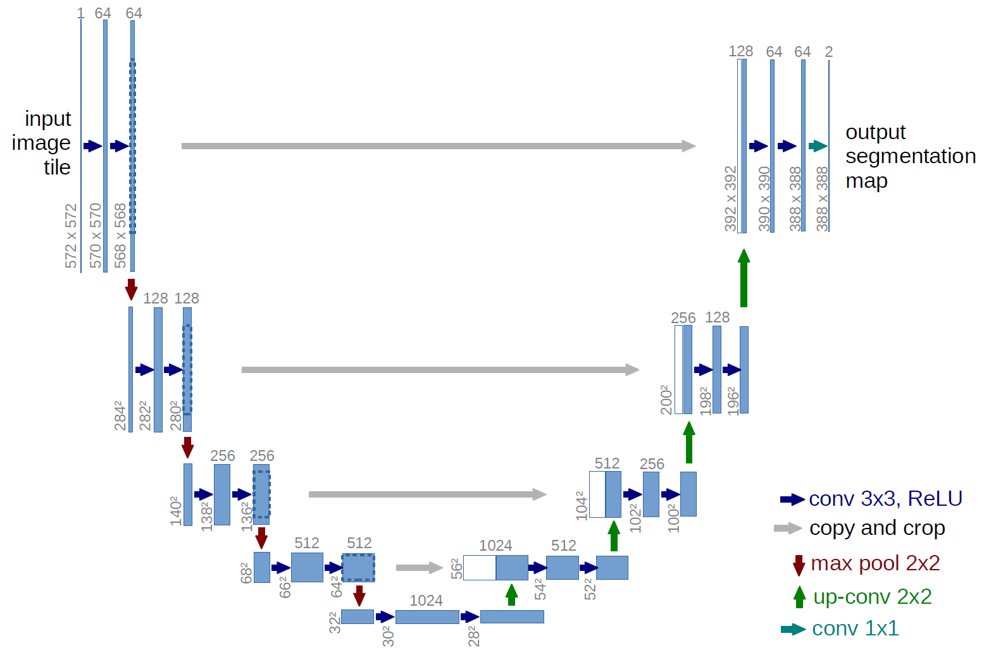

Fig 1: U-net Architecture

Our advanced model adopts the U-Net architecture, consisting of five encoder and four decoder layers. Each layer is enriched with essential components, including the rectified linear unit (ReLU) activation function, batch normalization, and max-pooling. The training regimen initiates with a learning rate of 1e-4, progressively decreasing it throughout the 150 epochs. Employing the Adam optimizer and the Dice coefficient loss function, the U-Net model undergoes meticulous training to refine its parameters. The culmination is marked by the output layer, where the sigmoid activation function imparts the final touch to this powerful U-Net-based neural network.

4. A **TIFF** format for our dataset stands for Tag Image File Format, which is a computer file used to store raster graphics and image information. TIFFs are a handy way to store high-quality images before editing if you want to avoid lossy file formats.

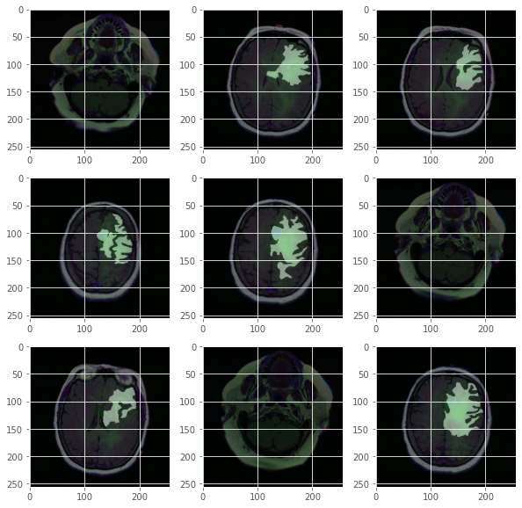

Fig 2: Images of the data with an overlay of the mask

**3. Our metrics**

1. Accuracy: The metric is used to evaluate the performance of binary classification models. It measures the percentage of correctly predicted labels compared to the true labels. The function uses a threshold of 0.5 to round the predicted values to the nearest binary class. The accuracy is calculated as the mean of the element-wise equality between the true and predicted labels. The resulting value ranges from 0 to 1, with 1 indicating perfect binary classification accuracy.

2. Dice coefficient: This metric computes the Dice coefficient, a metric commonly used for measuring the similarity between two binary images. In the context of image segmentation, it evaluates the overlap between the predicted and true segmentation masks. The formula involves the summation of the element-wise product of flattened true and predicted masks, along with smoothing for numerical stability. The Dice coefficient ranges from 0 to 1, with 1 indicating a perfect overlap.

3. Dice_coef_loss: This metric calculates the negative Dice coefficient, which is typically used as a loss function for training neural networks in segmentation tasks. The negative coefficient is employed as an objective to be minimized during the training process, encouraging the network to improve segmentation accuracy.

4. IOU: This metric computes the Intersection over Union (IoU), also known as the Jaccard Index. IoU is another metric commonly used in image segmentation to measure the overlap between predicted and true masks. The formula involves the intersection and union of the masks, along with smoothing for numerical stability. The IoU ranges from 0 to 1, with 1 indicating a perfect match between the predicted and true masks.

**Related work**

1. UNet Architecture for Medical Image Segmentation: The seminal work of Ronneberger et al. introduced the UNet architecture, revolutionizing medical image segmentation. Their paper, "U-Net: Convolutional Networks for Biomedical Image Segmentation," demonstrated the efficacy of UNet in various biomedical applications, providing a solid foundation for subsequent research in the field.
2. Application of UNet in Brain MRI Segmentation: Numerous studies have harnessed the power of UNet for brain MRI segmentation tasks. Notably, the work of Çiçek et al. in "3D U-Net: Learning Dense Volumetric Segmentation from Sparse Annotation" showcases the extension of UNet to three-dimensional contexts, enhancing its capability to capture volumetric details in brain structures.
3. Leveraging UNet for Brain Tumor Segmentation: In the specific domain of brain tumor segmentation, the research by Myronenko et al. in "3D MRI brain tumor segmentation using autoencoder regularization" demonstrates the successful application of UNet-based models. The paper emphasizes the importance of regularization techniques, showcasing UNet's adaptability to enhance segmentation accuracy in the presence of limited annotated data.
4. Radiogenomics in Lower-Grade Gliomas: The intersection of radiomics and genomics in lower-grade gliomas is explored in the works of Mazurowski et al., as outlined in "Association of genomic subtypes of lower-grade gliomas with shape features automatically extracted by a deep learning algorithm" (Computers in Biology and Medicine, 2019). This research forms the basis for our investigation, as it establishes a connection between genomic subtypes and shape features extracted by deep learning algorithms.
5. Multi-Institutional Study on Radiogenomics:The study by Mazurowski et al. in "Radiogenomics of lower-grade glioma: algorithmically-assessed tumor shape is associated with tumor genomic subtypes and patient outcomes in a multi-institutional study with The Cancer Genome Atlas data" (Journal of Neuro-Oncology, 2017) expands the scope by incorporating multi-institutional data from The Cancer Genome Atlas (TCGA). This work is particularly relevant to our research, as it explores associations between tumor shape, genomic subtypes, and patient outcomes.

**Results**

Table 1: shows the value for each score for both the training and testing data sets.

|  | accuracy | Dice coef | iou | Dice coef loss | Val accuracy | Val Dice coef | Val iou | Val Dice coef loss |
| --- | --- | --- | --- | --- | --- | --- | --- | --- |
| U-net | 99.89 | 91.69 | 85.26 | -0.9209 | -99.84 | 90.67 | 83.14 | -0.903 |

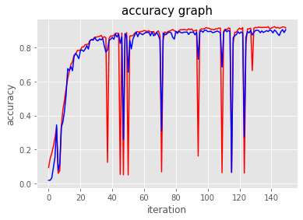

Fig 3: shows the evaluation of accuracy.

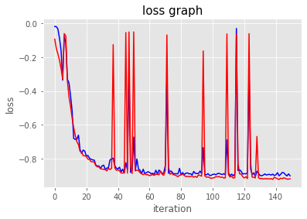

Fig 4: shows the evaluation of accuracy.

**Results**

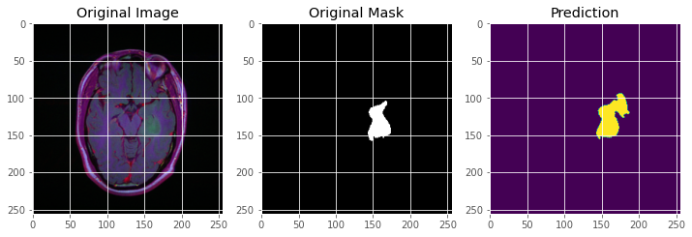

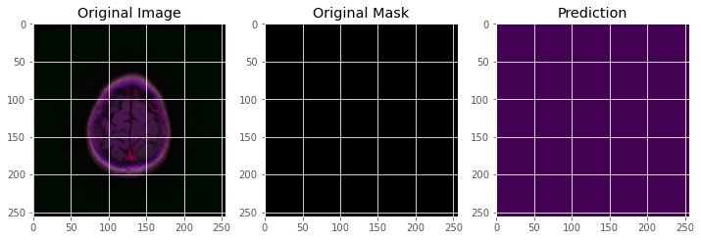

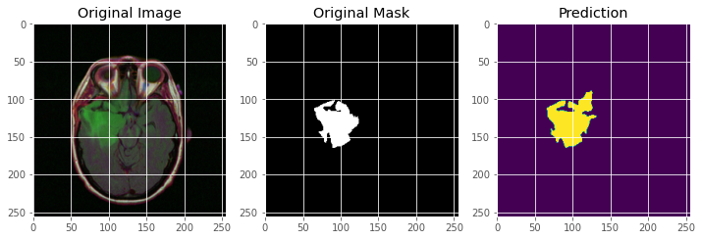

Fig 4: shows the predictions of our model.

**References**

1. Ronneberger, O., Fischer, P., & Brox, T. (2015). U-Net: Convolutional Networks for Biomedical Image Segmentation. Medical Image Computing and Computer-Assisted Intervention (MICCAI).

2. Çiçek, Ö., Abdulkadir, A., Lienkamp, S. S., Brox, T., & Ronneberger, O. (2016). 3D U-Net: Learning Dense Volumetric Segmentation from Sparse Annotation. International Conference on Medical Image Computing and Computer-Assisted Intervention (MICCAI).

3. Myronenko, A. (2018). 3D MRI brain tumor segmentation using autoencoder regularization. International Conference on Medical Image Computing and Computer-Assisted Intervention (MICCAI).

4. Buda, M., Saha, A., & Mazurowski, M. A. (2019). Association of genomic subtypes of lower-grade gliomas with shape features automatically extracted by a deep learning algorithm. Computers in Biology and Medicine.

5. Mazurowski, M. A., Clark, K., Czarnek, N. M., Shamsesfandabadi, P., Peters, K. B., & Saha, A. (2017). Radiogenomics of lower-grade glioma: algorithmically-assessed tumor shape is associated with tumor genomic subtypes and patient outcomes in a multi-institutional study with The Cancer Genome Atlas data. Journal of Neuro-Oncology.